Python – Get number of characters, words, spaces and lines in a file.

Given a text file fname, the task is to count the total number of characters, words, spaces and lines in the file.

As we know, Python provides multiple in-built features and modules for handling files. Let’s discuss different ways to calculate total number of characters, words, spaces and lines in a file using Python.

File1.txt

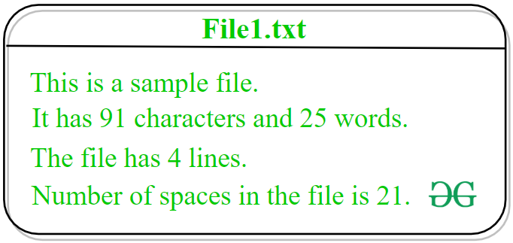

Method #1: Naive approach  
In this approach, the idea is to solve the task by developing our own logic. Without using any built-in function of Python, the total number of characters, words, spaces and lines of the file will be calculated.

Below is the implementation of the above approach.

# Python implementation to compute

# number of characters, words, spaces

# and lines in a file

# Function to count number

# of characters, words, spaces

# and lines in a file

def counter(fname):

# variable to store total word count

num_words = 0

# variable to store total line count

num_lines = 0

# variable to store total character count

num_charc = 0

# variable to store total space count

num_spaces = 0

# opening file using with() method

# so that file gets closed

# after completion of work

with open(fname, 'r') as f:

# loop to iterate file

# line by line

for line in f:

# incrementing value of

# num_lines with each

# iteration of loop to

# store total line count

num_lines += 1

# declaring a variable word

# and assigning its value as Y

# because every file is

# supposed to start with

# a word or a character

word = 'Y'

# loop to iterate every

# line letter by letter

for letter in line:

# condition to check

# that the encountered character

# is not white space and a word

if (letter != ' ' and word == 'Y'):

# incrementing the word

# count by 1

num_words += 1

# assigning value N to

# variable word because until

# space will not encounter

# a word can not be completed

word = 'N'

# condition to check

# that the encountered character

# is a white space

elif (letter == ' '):

# incrementing the space

# count by 1

num_spaces += 1

# assigning value Y to

# variable word because after

# white space a word

# is supposed to occur

word = 'Y'

# loop to iterate every

# letter character by

# character

for i in letter:

# condition to check

# that the encountered character

# is not white space and not

# a newline character

if(i !=" " and i !="\n"):

# incrementing character

# count by 1

num_charc += 1

# printing total word count

print("Number of words in text file: ", num_words)

# printing total line count

print("Number of lines in text file: ", num_lines)

# printing total character count

print('Number of characters in text file: ', num_charc)

# printing total space count

print('Number of spaces in text file: ', num_spaces)

# Driver Code:

if __name__ == '__main__':

fname = 'File1.txt'

try:

counter(fname)

except:

print('File not found')

**Output:**

Number of words in text file: 25

Number of lines in text file: 4

Number of characters in text file: 91

Number of spaces in text file: 21

**Method #2: Using some built-in functions and OS module functions**  
In this approach, the idea is to use the os.linesep() method of OS module to separate the lines on the current platform. When the interpreter’s scanner encounter os.linesep it replaces it with \n character. After that strip() and split() functions will be used to carry out the task.  
Get more idea about [strip()](https://www.geeksforgeeks.org/python-string-strip/) and [split()](https://www.geeksforgeeks.org/python-string-split/) functions.

Below is the implementation of the above approach.

|  |
| --- |
| # Python implementation to compute  # number of characters, words, spaces  # and lines in a file    # importing os module  import os    # Function to count number  # of characters, words, spaces  # and lines in a file  def counter(fname):        # variable to store total word count      num_words = 0        # variable to store total line count      num_lines = 0        # variable to store total character count      num_charc = 0        # variable to store total space count      num_spaces = 0        # opening file using with() method      # so that file gets closed      # after completion of work      with open(fname, 'r') as f:            # loop to iterate file          # line by line          for line in f:                # separating a line              # from \n character              # and storing again in line              # variable for further operations              line = line.strip(os.linesep)                # splitting the line              # to make a list of              # all the words present              # in that line and storing              # that list in              # wordlist variable              wordslist = line.split()                # incrementing value of              # num_lines with each              # iteration of loop to              # store total line count              num_lines = num_lines + 1                # incrementing value of              # num_words by the              # number of items in the              # list wordlist              num_words = num_words + len(wordslist)                # incrementing value of              # num_charc by 1 whenever              # value of variable c is other              # than white space in the separated line              num_charc = num_charc + sum(1 for c in line                            if c not in (os.linesep, ' '))                # incrementing value of              # num_spaces by 1 whenever              # value of variable s is              # white space in the separated line              num_spaces = num_spaces + sum(1 for s in line                                  if s in (os.linesep, ' '))        # printing total word count      print("Number of words in text file: ", num_words)        # printing total line count      print("Number of lines in text file: ", num_lines)        # printing total character count      print("Number of characters in text file: ", num_charc)        # printing total space count      print("Number of spaces in text file: ", num_spaces)    # Driver Code:  if __name__ == '__main__':      fname = 'File1.txt'      try:          counter(fname)      except:          print('File not found') |

**Output:**

Number of words in text file: 25

Number of lines in text file: 4

Number of characters in text file: 91

Number of spaces in text file: 21